

Dipa das

[Email address]

Water pollution

Submitted To:

Dipa Das

Public Administration

University Of Barisal

Contents

❖ **Abstract** 2

❖ **Introduction** 2

❖ **Types of Water Pollution** 4

**1. Surface Water Pollution** 4

**2. Groundwater Pollution** 4

**3. Marine Pollution** 4

**4. Microbiological Pollution** 5

**5. Chemical Pollution** 5

**6. Thermal Pollution** 5

**7. Nutrient Pollution (Eutrophication)** 5

**8. Oil Pollution** 6

**9. Plastic Pollution** 6

**10. Radioactive Pollution** 6

**11. Sediment Pollution** 6

**12. Pathogenic Pollution** 6

❖ **Causes of Water Pollution** 7

**1. Industrial Waste** 7

**2. Agricultural Activities** 7

**3. Sewage and Wastewater** 7

**4. Oil Spills** 7

**5. Plastic Pollution** 7

**6. Urban Runoff** 7

**7. Deforestation and Soil Erosion** 7

**8. Mining Activities** 8

**9. Thermal Pollution** 8

**10. Marine Dumping** 8

**11. Atmospheric Deposition** 8

**12. Leakage from Landfills** 8

❖ **Data Collection Methods** 8

**1.Primary Data:** 8

**2.Secondary Data:** 9

**3.Water Sample and Photograph:** 9

**4.Recent Surface water Quality:** 9

**5.Water Quality:** 9

**6. Focus Group Discussions:** 9

❖ **Determination of Water Quality Parameters** 9

**Dissolved Oxygen (DO):** 9

❖ **Effects of Water Pollution** 10

**1. Effects on Human Health:** 11

**2. Effects on Aquatic Life** 11

**3. Ecosystem Disruption** 11

**4. Economic Impacts** 12

**5. Impact on Agriculture** 12

**6. Global Environmental Impacts** 12

❖ **Results and Discussions** 12

• **Health Problem:** 12

• **Community Perceptions of Health Profile** 12

❖ **Control of Water Pollution** 14

❖ **CONCLUSIONS** 16

❖ **References:** 17

**Water Pollution**

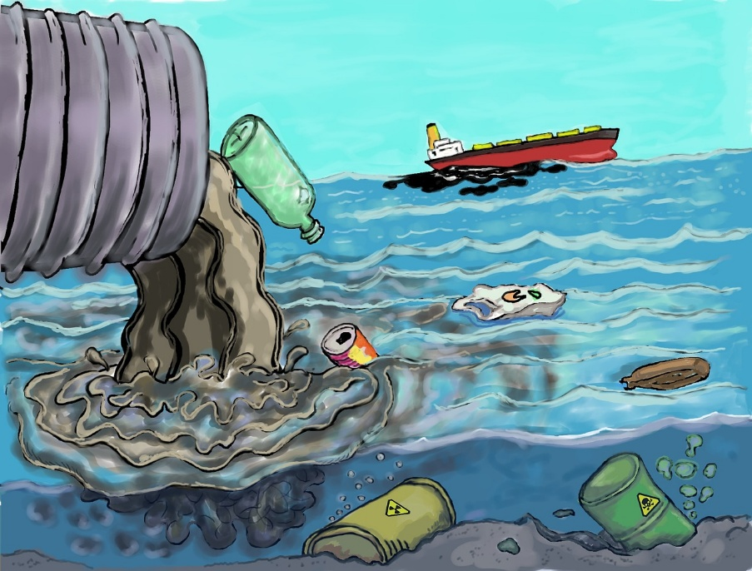

# **Abstract**

River pollution has been one of the main topics in the environmental issue of urban Dhaka, the capital city of Bangladesh. This study was conducted to find out the pollution situation of Turag river and the health problem of the surrounding residents. The results clearly determine that the water quality of Turag river may not be in a position to sustain the aquatic life and not suitable for using domestic purpose. This is indicated by the very low dissolved oxygen (DO) levels and other measured parameters in the river. The maximum recorded values of pH, colour, turbidity, biochemical oxygen demand (BOD5), hardness, total dissolved solids (TDS), chloride (Cl-), carbon-di-oxide (CO2) and chemical oxygen demand (COD) were 7.1 mg/L, 625 ptcu, 97.2, 4.65 mg/L, 1816 mg/L, 676mg/L, 5 mg/L, 15.5, and 78 mg/L, respectively. The Keywords: maximum concentration of turbidity, BOD, hardness, TDS, and COD found in the Turag river is much higher than the standard permissible limit. The study also provides evidence that local communities are suffering from a variety of health problems including skin, diarrhoea, dysentery, respiratory illnesses, anaemia and complications in childbirth. Yellow fever, cholera, dengue, malaria and other epidemic diseases are also available in this area. Furthermore, the people are suffering by the odour pollution and respiratory problems.

# **Introduction**

Water is the most vital element among the natural resources, and is critical for the survival of all living organisms including human, food production, and economic development. Today there are many cities worldwide facing an acute shortage of water and nearly 40 percent of the world’s food supply is grown under irrigation and a wide variety of industrial processes depends on water. The environment, economic growth, and developments are all highly influenced by water-its regional and seasonal availability, and the quality of surface and groundwater. The quality of water is affected by human activities and is declining due to the rise of urbanization, population growth, industrial production, climate change and other factors. The resulting water pollution is a serious threat to the well-being of both the Earth and its population. Bangladesh is a deltaic land created and flown over by numerous rivers; the land is also consistently nourished by their water flows. Pollution of river bodies has become a major problem that is becoming critical because of inadequacy or non-existence of surface water quality protection measures and sanitation. Lagoons, rivers and stream are sinks for wastes. Wastes are most often discharged into the receiving water bodies with little or no regard to their assimilative capacities. The discharge of raw sewage, garbage, as well as oil spills are threats to the diluting capabilities of the lagoons and rivers in the major cities. The natural purification of polluted waters in itself is never fast, while heavily polluted water may traverse long distance in days before a significant degree of purification is achieved. In addition, rivers and canals are becoming increasingly polluted from industrial wastewater dumped by factories, many of them in the textile industry. Leather tanneries are also a significant source of toxic pollutants to the air and water. The water pollution threatens food production and is raising both environmental and human health concerns.

Dhaka city is surrounded by a number of rivers and canals of which Turag, Buriganga, Dhaleshwari, Balu and Shitalakhya are the important ones. Because of the lack of the water resources management plan and policies, both the quality and quantity of water in these rivers have reached a very critical situation that does not allow its instant use. The rivers Buriganga, Shitalakhya, Turag, and Balu have been so extremely polluted that these have turned into the rivers of poison. The poisonous waters of these rivers have not only been killing all its aquatic life but also been posing health hazards to the dwellers of the city. These rivers receive partially treated and untreated sewage effluent, sewage polluted surface run-off and untreated industrial effluent from nearby residential and industrial areas. Sources of pollution of the water in these rivers also include various industrial discharge, domestic waste; indiscriminate throwing of pathological and commercial wastes, etc. Because of this, water quality of these rivers is deteriorating day by day.

River pollution has been one of the main topics in the environmental issue of urban Dhaka. The rivers surrounding the capital city, including the Turag have been steadily experiencing complicated problems like pollution and encroachment that have almost suffocated these valuable lifelines of the city [14–16]. The pollution of the Turag river found in two points with extreme pollution especially from the Buriganga third bridge to the Tongi bridge. These two pollution points of the river homing in on the sources and causes of pollution, its impacts on the surrounding environment and possible sustainable remedies. However, the specific objectives of the study were as follows:

1. To show the variations in different water quality parameters along a strip of the river due to the disposal of untreated industrial waste and season change (dry and wet); and

2. To analyse the health problems created by the pollution.

* **Types of Water Pollution**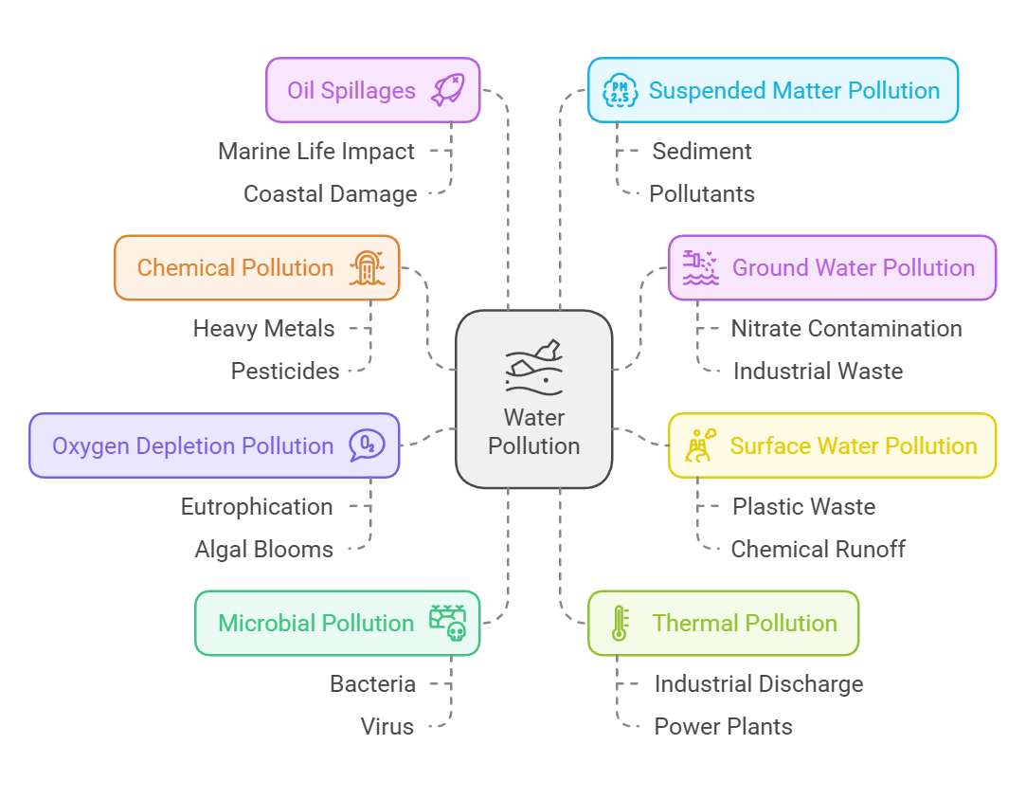

Water pollution is the contamination of water bodies (such as rivers, lakes, oceans, and groundwater) by harmful substances. It can be categorized into several types based on the source and nature of the pollutants:

## **1. Surface Water Pollution**

**Definition:**

Pollution affecting water bodies on the surface, such as rivers, lakes, and oceans.

**Sources:**

* Industrial waste discharge.
* Agricultural runoff containing pesticides and fertilizers.
* Urban sewage and littering.

## **2. Groundwater Pollution**

**Definition:**

Contamination of underground water sources like aquifers.

**Sources:**

* Leaching of chemicals from landfills.
* Excessive use of fertilizers and pesticides.
* Oil spills and seepage from underground tanks.

## **3. Marine Pollution**

**Definition:** Pollution of oceans and seas.

**Sources:**

* Dumping of industrial waste and plastics.
* Oil spills from ships and drilling operations.
* Excessive nutrients leading to eutrophication.

## **4. Microbiological Pollution**

**Definition:**

Contamination by microorganisms like bacteria, viruses, and parasites.

**Sources:**

* Untreated sewage.
* Agricultural runoff containing animal waste.
* Improper disposal of human waste.

## **5. Chemical Pollution**

**Definition:**

Contamination from harmful chemicals.

**Sources:**

* Pesticides, herbicides, and industrial chemicals.
* Heavy metals like mercury and lead.
* Detergents and household chemicals.

## **6. Thermal Pollution**

**Definition:**

Increase in water temperature caused by human activities.

**Sources:**

* Discharge of hot water from power plants and industries
* .Deforestation reducing shade over water bodies.

## **7. Nutrient Pollution (Eutrophication)**

**Definition:**

Excessive nutrients, such as nitrogen and phosphorus, in water bodies.

**Sources:**

* Fertilizer runoff.
* Wastewater containing detergents.
* Agricultural and livestock operations.

## **8. Oil Pollution**

**Definition:**

Contamination by oil and petroleum products.

**Sources:**

* Oil spills from tankers.
* Leakage from pipelines and offshore drilling.
* Runoff from roads and industries.

## **9. Plastic Pollution**

**Definition:**

Accumulation of plastic and microplastics in water bodies.

**Sources:**

* Improper disposal of plastic waste.
* Breakdown of larger plastics into microplastics.

## **10. Radioactive Pollution**

**Definition:**

Contamination from radioactive substances.

**Sources:**

* Nuclear power plant discharges.
* Improper disposal of radioactive waste.
* Mining and processing of radioactive materials.

## **11. Sediment Pollution**

**Definition:**

Excessive sediments in water, often due to soil erosion.

**Sources:**

* Deforestation and agriculture.
* Construction activities.
* Mining operations.

## **12. Pathogenic Pollution**

**Definition:**

Presence of disease-causing organisms in water.

**Sources:**

* Contaminated water sources.
* Animal waste and untreated sewage.

# **Causes of Water Pollution**

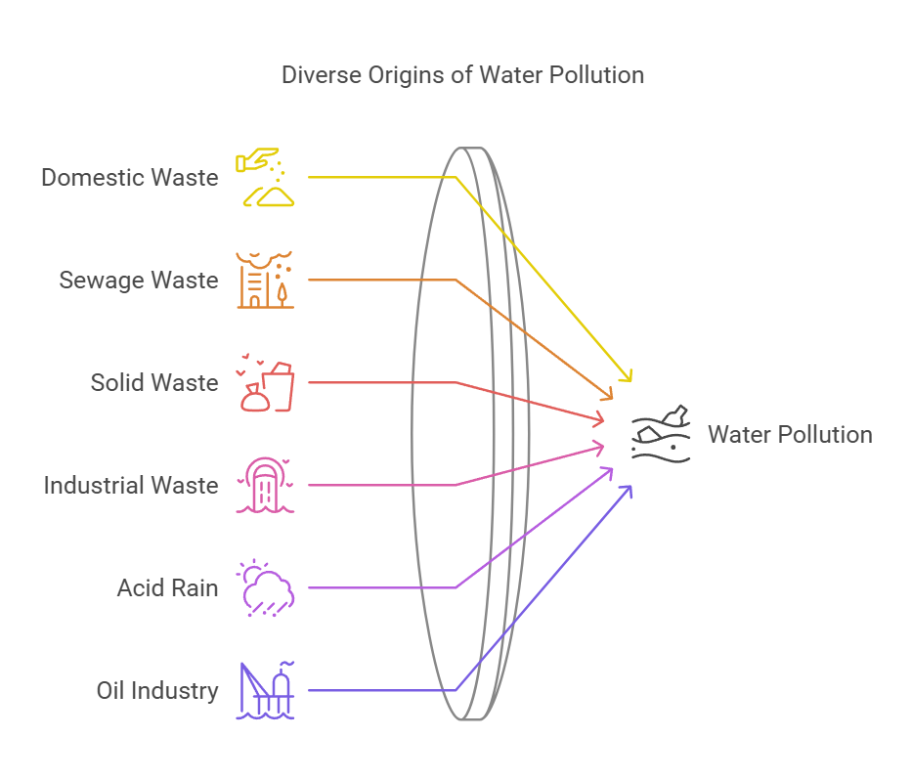

## **1. Industrial Waste**

Factories discharge chemicals, heavy metals, and toxic substances into water bodies, often without adequate treatment.

## **2. Agricultural Activities**

Fertilizers, pesticides, and animal waste runoff contaminate rivers and lakes, causing nutrient pollution and eutrophication.

## **3. Sewage and Wastewater**

Untreated or poorly treated sewage introduces harmful pathogens, organic waste, and nutrients into water systems.

## **4. Oil Spills**

Accidental oil spills and leaks from ships and drilling sites pollute oceans and coastal areas.

## **5. Plastic Pollution**

Dumping plastics and other non-biodegradable materials clogs waterways and harms aquatic life.

## **6. Urban Runoff**

Rainwater washes pollutants like motor oil, chemicals, and litter from streets and urban areas into water bodies.

## **7. Deforestation and Soil Erosion**

Deforestation leads to soil erosion, which increases sedimentation in rivers and lakes, disrupting aquatic ecosystems.

## **8. Mining Activities**

Mining releases heavy metals and chemicals, contaminating surface and groundwater.

## **9. Thermal Pollution**

Industries and power plants release heated water into natural water bodies, altering their ecosystems.

## **10. Marine Dumping**

Dumping solid waste, hazardous chemicals, and sewage into oceans pollutes marine environments.

## **11. Atmospheric Deposition**

Pollutants from the air, such as sulfur dioxide and nitrogen oxides, dissolve in rain, leading to acid rain and water contamination.

## **12. Leakage from Landfills**

Toxic substances from poorly managed landfills seep into groundwater, polluting it.

# **Data Collection Methods**

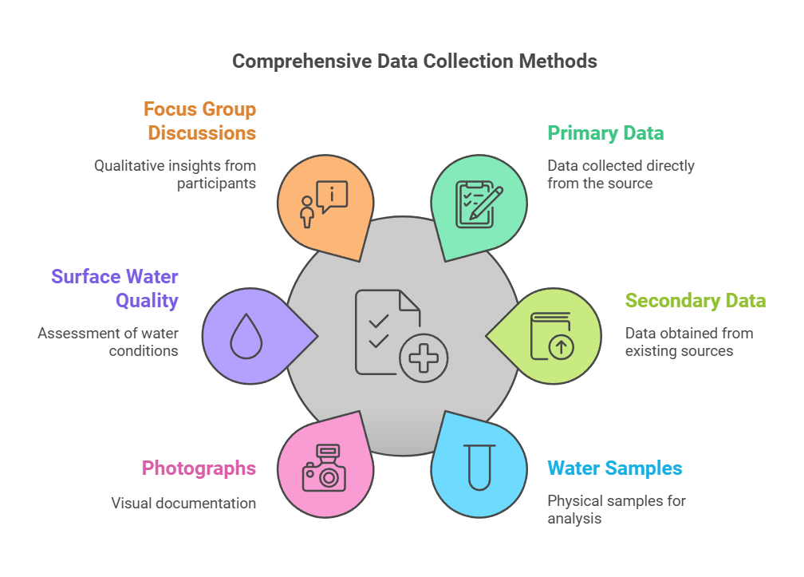

The steps that have been adopted to attain the objectives of the study were as follows:

## **1.Primary Data:**

Primary data were obtained from field observation and this was needed to know about the existing physical and environmental condition of the study.

## **2.Secondary Data:**

Secondary data have been collected from DOE, BWDB, BUET and IWM, special report the Turag project of the Bangladesh Centre for Advance Studies.

## **3.Water Sample and Photograph:**

Water Samples and photographs have been collected from different locations of the Turag river and water samples tested in the MIST Environmental Engineering laboratory.

## **4.Recent Surface water Quality:**

## Recent surface water quality data has been collected from DOE and Environmental laboratory in Civil Engineering department of BUET as test sample.

## **5.Water Quality:**

Water quality and pollution loads analysed to find out the present water quality scenario, trend of water pollution and percent of increase in pollution loading. Besides, reports, thesis, journals and expert opinions were collected from different organizations and internet.

## **6. Focus Group Discussions:**

Focus group discussions (FGDs) and in-depth interviews with community members to identify their perceived current and historical health problems.

# **Determination of Water Quality Parameters**

|  |  |
| --- | --- |
| **Parameter** | **Standard** |
| DO | 6mg/L |
| pH | 6.5-8.5 |
| Colour | 15 ptcu |
| Turbidity | 10 NTU |
| BOD | 0.2 mg/L |
| Hardness | 200-500mg/L |
| TDs | 1000 |
| Cl | 0.2mg/L |
| CO2 | - |
| COD | 4mg/L |

**Dissolved Oxygen (DO):** The sample was taken in the bottle and diluted with the water. The probe of the MultiMate was placed inside the bottle and the reading is taken.

**pH:** The sample water is taken in small beaker then the probe of the pH meter is placed inside the water and kept for some time. The reading was shown on the pH meter but the final value took when the reading on the screen became static.

**Colour**: The sample water is taken on the small beaker of the spectrophotometer. The spectrophotometer is set for the colour test and it is zeroed by the distilled water. Then the sample water is placed inside the spectrophotometer and reading is taken.

**Turbidity:** The sample water was taken in the small tube of the turbidity meter. The switched was on and then the reading was taken from the meter.

**Biochemical Oxygen Demand (BOD5):** The sample was taken in the bottle and diluted with the water. The probe of the multimixer was placed inside the bottle and the reading was taken and finally the bottle was placed inside the refrigerator at 200 ˚ C of temperature for 5 days. After 5 days, the data was taken again trough the multi metered the result was obtained.

**Hardness:** The 50 ml of sample water was taken in the beaker which was diluted with 50 ml of distilled water. Then 1 ml starch in a packet of reagent was added with the water which was then titrated. However, the reading was taken when the colour become purple.

Total Dissolved Solids (TDS): The sample water was taken in the beaker and the probe of the multimixer was placed inside the beaker for few minute. The static result shown on the screen of the multimixer was the TDS of the water.

**Chloride (Cl−):** Filled a square sample cell with 10 ml of sample and another one with deionized water sample pipette 1.0 ml of Mercuric Thiocyanate solution into each sample. Sample was then swirl to mix. Pipette 0.5 ml of Ferric Ion solution into each sample cell and kept the sample for two minutes. After that two cells were placed inside the spectrophotometer and the results were obtained.

**Carbon-di-Oxide (CO2):** First we took 100ml of the sample, 3 drops of the Phenaphtholen was added to thesample if the sample goes pink it represents no CO2 is present, otherwise three drops of Methylorange was added with the sample. Later titration was done with NAOH. Five times of NAOH of titration was the amount of CO2 present in the sample.

**Chemical Oxygen Demand (COD):** Turned on the reactor and pre heated to 150 ˚ C. Hold the vial at 45 degree angle and 2 ml of sample. Then the sample was mixed by inverting the vial. The sample was heated for two hours with a strong oxidizing agent. After the vial was placed inside, the spectrophotometer and compared it with the blank vial. Thus the result was obtained.

# **Effects of Water Pollution**

Water pollution has far-reaching consequences on human health, aquatic ecosystems, and the environment. Key effects include:

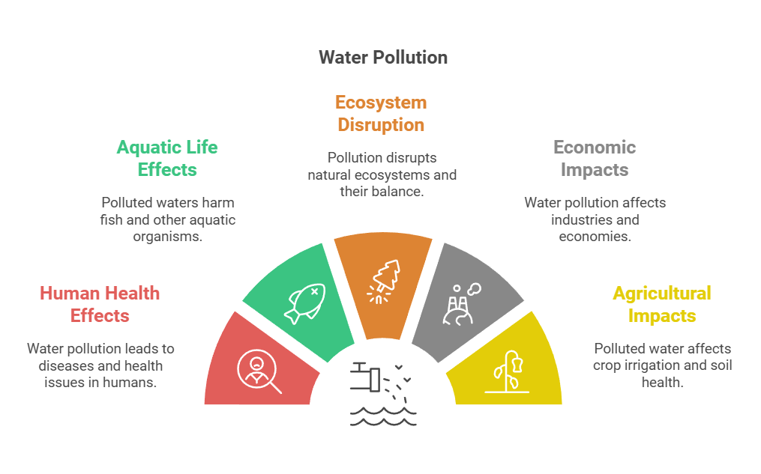

## **1. Effects on Human Health:**

Waterborne Diseases: Contaminated water can cause diseases like cholera, dysentery, typhoid, and hepatitis.

**Toxicity:** Consumption of polluted water with heavy metals like mercury and lead can lead to neurological, kidney, and liver damage.

**Chemical Exposure:** Long-term exposure to pesticides and industrial chemicals in drinking water increases cancer risks and hormonal imbalances.

# **2. Effects on Aquatic Life**

**Eutrophication:** Excess nutrients cause algal blooms, depleting oxygen in water and killing aquatic species.

**Toxic Contamination:** Pollutants like oil, plastics, and chemicals harm fish, amphibians, and marine animals, disrupting food chains.

**Loss of Biodiversity:** Persistent pollution leads to the extinction of sensitive aquatic species.

# **3. Ecosystem Disruption**

**Sedimentation:** Soil erosion increases sediment levels in water, suffocating aquatic plants and animals.

**Temperature Changes:** Thermal pollution disrupts ecosystems by altering habitats unsuitable for native species.

**Habitat Destruction:** Pollutants damage coral reefs, wetlands, and other critical habitats.

# **4. Economic Impacts**

**Decline in Fisheries:** Polluted water bodies reduce fish populations, affecting livelihoods in fishing communities.

**Tourism Loss:** Polluted beaches, rivers, and lakes deter tourists, harming local economies.

**Increased Treatment Costs:** Governments and industries spend more on purifying water for safe consumption.

# **5. Impact on Agriculture**

**Contaminated Irrigation:** Polluted water affects soil health and crop yields, introducing harmful toxins into the food chain.

**Livestock Health:** Animals consuming polluted water suffer from diseases, reducing productivity.

# **6. Global Environmental Impacts**

**Ocean Pollution:** Plastic debris and toxic waste affect marine ecosystems globally, impacting biodiversity and climate regulation.

**Climate Effects:** Polluted water sources contribute to greenhouse gas emissions like methane from stagnant polluted water.

# **Results and Discussions**

## **Health Problem:**

On this part of study the main target was to find out the health problems which are create by the industrial pollutant waste water discharged and flow into the river. The visions of this part of the study were:

1. Assess the prevalent health conditions of the people living around river and prepare a health profile;

2. Identify potential or evidence derived environmental factors associated with those prevalent health problems; and

3. Identify potential pollution related health indicators.

## **Community Perceptions of Health Profile**

In an open question on predominant health problems in the community, the respondents mentioned that skin diseases, diarrhoea , gastric ulcers, and respiratory illnesses (common cold, asthma) were the most common health problems amongst the

population in the area. In addition, people also suffer from indigestion, hypertension, gout, rheumatism, conjunctivitis, pneumonia, malaria, tuberculosis and cancer. At least 70 percent of the people involved in the discussions reported that they were suffering from skin diseases, diarrhoea, gastric ulcers or other gastric

* problems at the time that the research was taking place.

|  |  |  |  |
| --- | --- | --- | --- |
| **Health Problem** | **Sum of Score** | **Mean± SD** | **Rank** |
| Skin disease | 78 | 7.80±3.52 | 1 |
| Diarrhoea | 76 | 7.60±4.62 | 2 |
| Gastric ulcer | 75 | 7.50±8.09 | 3 |
| Fever | 50 | 4.10±5.67 | 4 |
| Cold, cough | 44 | 4.40±5.82 | 5 |
| Dysentery | 40 | 4.00±5.72 | 6 |
| Cold cough and fever | 8 | 0.80±2.53 | 7 |
| A.R.I | 16 | 1.60±5.06 | 8 |
| Pneumonia | 15 | 1.50±3.17 | 9 |
| Indigestion | 14 | 1.40±2.95 | 10 |
| Amoebiasis | 12 | 1.20±3.7 | 11 |
| Chicken pox | 10 | 1.00±3.16 | 12 |
| Hypertension | 10 | 1.00±3.16 | 13 |
| Acute Abdomen | 10 | 1.00±3.16 | 14 |
| Spermatorrhoea | 8 | 0.80±2.53 | 15 |
| Gout | 8 | 0.80±2.53 | 16 |
| Headache | 5 | 0.50±1.58 | 17 |

* In this interview cold, cough and fever was treated as a single health problem as even after questioning the health worker was unable to separate them and considered them to be a problem that always occurred together.

Qualitative information suggests that there may be a link between the pollution and health problems. Skin problems, allergic conditions, itching and other skin lesions are contact-type diseases. It found that the alkali water, which is likely to be attributable to the extensive use of the alkalis soda ash and caustic soda in the textile dyeing industry.

This alkalinity is likely to be a key factor in the skin irritations reported by local communities as they reported that the symptoms manifest themselves when their skin has come into physical contact with water or sediment. Skin problems were very widespread in the study area. Almost all participants of interview claimed to have experienced skin problems because of their frequent contact with water, and some participants were currently suffering from skin problems. They willingly showed the team the skin lesions in their bodies, particularly in hands and legs. While talking to the local doctors and village practitioners, it was found that the drugs for skin problems, both traditional and allopathic, were the highest selling drugs in the locality. The symptoms of the skin conditions include a rash, boils and irritation. There are two main reasons given by the communities as to the source of the problem. The first is that it is spread by contact especially among children who are living in unhealthy environments. The second and more frequently reported cause is contact with the chemicals used in the factories. The people here come into contact with the river water whilst using it for agricultural purpose or when they come for fishing [17].

The majority of the respondents also blamed the lack of proper sanitation systems, poultry farm waste and lack of knowledge about hygiene for diarrhoea and dysentery, which are frequent among children, slum dwellers and factory workers. Diarrhoea is one of the most prevalent health problems reported to be suffered by children.

Gastric ulcers have been identified as a common health problem for workers in the area, including factory workers.

The doctors and health workers interviewed felt that this was due to irregular eating habits and the length of time between meals and the drinking unsafe drinking water. Respiratory disorder was highlighted as a major problem in the study area and participants in also mentioned the problem of asthma. Although this may be caused by a number of factors studies have shown that occasional high concentrations of hydrogen sulphide found in community air samples were consistent with complaints of headaches, eye irritation, and sore throats. Exposure of 42 individuals to 2.5 to 5

ppm (3.5 to 7 mg/m3) hydrogen sulphide caused coughing and throat irritation after 15 minutes. In addition there is a large body of evidence that shows that textile dyes can act as respiratory sensitizers and can lead to choughs, respiratory tract irritation and asthma.

# **Control of Water Pollution**

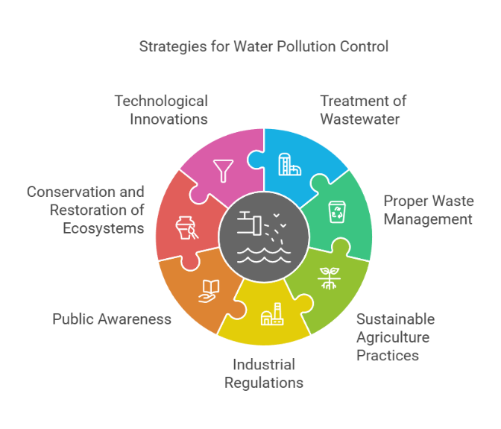

Controlling water pollution requires effective strategies at individual, community, and governmental levels. Below are key measures:

**1. Treatment of Wastewater**

**Industrial Effluents:** Treat industrial waste before discharge through filtration, sedimentation, and chemical processes.

**Sewage Treatment**: Establish and upgrade sewage treatment plants to remove harmful contaminants.

**Reuse and Recycling**: Promote the reuse of treated wastewater for irrigation and industrial processes.

**2. Proper Waste Management**

**Reduce Plastic Use:** Minimize single-use plastics and encourage recycling.

**Landfill Management:** Prevent toxic leachate from landfills by using impermeable liners and proper waste segregation.

**Marine Waste Reduction:** Ban dumping of hazardous and solid waste into oceans and river.

**3. Sustainable Agricultural Practices**

**Organic Farming:** Reduce the use of chemical fertilizers and pesticides, opting for organic alternatives.

**Buffer Zones:** Establish vegetation along riverbanks to reduce agricultural runoff.

**Efficient Irrigation:** Use water-efficient systems like drip irrigation to prevent overuse and contamination.

**4. Industrial Regulations**

**Strict Enforcement:** Enforce environmental laws to regulate industrial discharge and impose penalties for violations.

**Eco-Friendly Technologies:** Encourage industries to adopt cleaner production methods and technologies.

**5. Public Awareness and Education**

**Community Participation:** Involve local communities in clean-up drives and monitoring water quality.

**Education Campaigns:** Raise awareness about water conservation and pollution control through schools, media, and social platforms.

**6. Conservation and Restoration of Ecosystems**

**Protect Wetlands**: Conserve wetlands as natural water filters and habitats for aquatic life.

**Reforestation:** Plant trees to prevent soil erosion and sedimentation in water bodies.

**Clean Water Initiatives:** Regularly clean polluted rivers, lakes, and beaches.

**7. Technological Innovations**

**Water Purification:** Use advanced technologies like reverse osmosis, UV treatment, and nanotechnology for clean water.

**Monitoring Systems:** Deploy sensors and satellite systems to monitor pollution levels in real time.

**8. International Cooperation**

**Global Agreements:** Support international treaties like the Marine Pollution Convention to address transboundary water pollution.

**Funding and Research:** Collaborate on global research and provide financial aid to developing countries for pollution control.

**9. Individual Actions**

Avoid littering near water bodies.

Use eco-friendly household products.

Practice water conservation techniques, like fixing leaks and reducing wastage.

# **CONCLUSIONS**

The results of the sampling programme clearly determine that the water quality of Turag river may not be in a position to sustain the aquatic life as well as not suitable for using for domestic purpose. Due to lack of time and resources, the sampling programme was limited to four months duration, from April 2013 to July 2013. The water samples were analysed that includes DO, pH, colour, turbidity, BOD5, hardness, TDS, chloride, CO2, COD etc. The disposal of industrial waste effluent into riverine system has given rise to heavily localized pollution and threatens seriously to the environment. The present data on the status of river water will help to establish water processing plants in future, the requirement of which increases at a tremendous rate due to growth of population, industrialization and arsenic contamination in ground water. The maximum concentration of turbidity, BOD, hardness, TDS and COD found in the Turag river is much higher than the standard permissible limit. The pollution level of the river is increasing sharply and can cause serious problem in near future. From this study, the surface water quality of then major rivers around Dhaka city, is a great threat to ecosystem though some parameters may not in the deteriorate level but the condition of the river side urbanization and industrialization may cause all kind of water pollution in the near future.

On the other hand, the study provides evidence that local communities are suffering from a variety of health problems that could be a direct or indirect result of the discharge and flow of waste water. Skin problems may for example be related to the high pH of the water, which could certainly irritate the skin and result in sores. The high pH levels are likely to be the result of the large quantities of caustic soda and soda ash used in the dyeing process. It is more difficult to attribute the stomach problems to industrial pollution as people in the area do not drink surface water. However gastric ulcers and other similar gastric problems may be related to diet and the impacts of the pollution on crops and fish consumed by people living around Turag river.

# **References:**